1. **Alarm should sound in one manner temperature is above60C**

**(circuitdiagram)**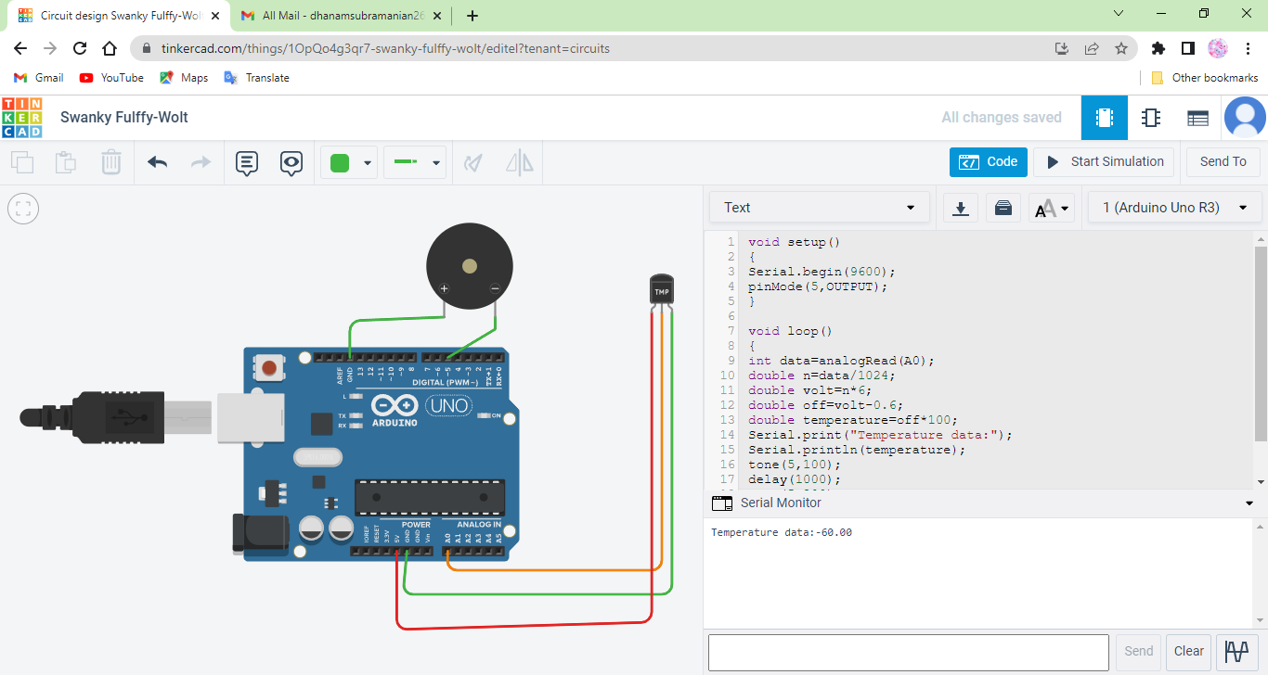

**CODING FOR CIRCUIT:**

void setup()

{

Serial.begin(9600);

pinMode(5,OUTPUT);

}

void loop()

{

int data=analogRead(A0);

double n=data/1024;

double volt=n*6;

double off=volt-0.6;

double temperature=off*100;

Serial.print(“Temperature data”);

Serial.println(temperature);

tone(5,100);

delay(1000)**;**

tone(5,200);

delay(1000);

**}**

**2.Alarm should sound with another frequency if motion is detected in PIR sensor**

**(circuitdiagram)**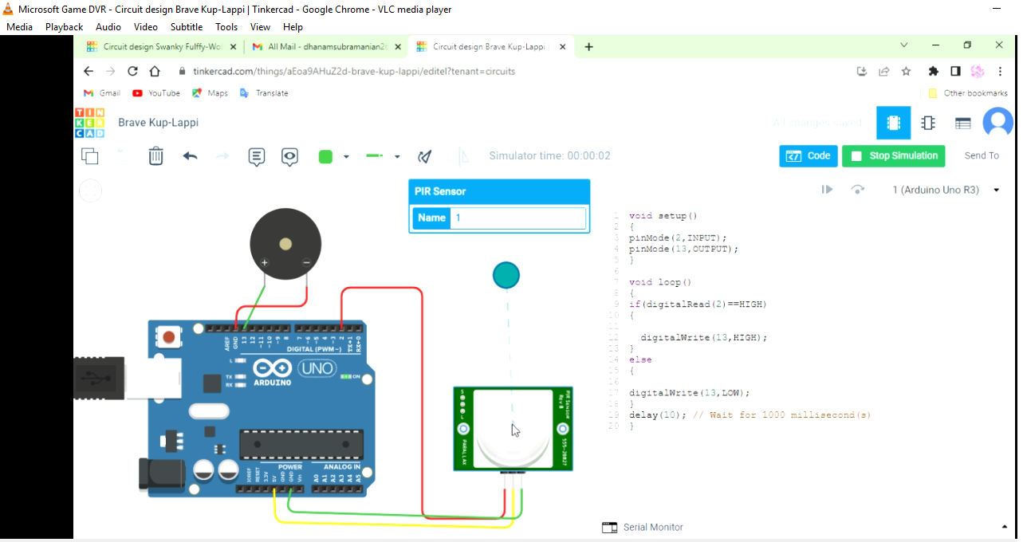

**CODING FOR CIRCUIT**

void setup()

{

pinMode(2,INPUT);

pinMode(13,OUTPUT);

}

void loop()

{

if(digitalRead(2)==HIGH)

{

digitalWrite(13,HIGH);

}

else

{

digitalWrite(13,LOW);

}

delay(10); // Wait for 1000 millisecond(s)

}